TASK 1

1. "passwd", "chsh", "su", and "sudo" commands need to access certain files that can only be accessed by a root user. But there will be times when a normal user would want to make changes to these files. So instead of giving all users root privilege, we can make these setUID programs so that the user will be granted root privileges only while running these programs.
2. Without the root privilege, a normal user will not be able to access and edit the files required for the successful completion of the above commands. Hence the user will not be able to run the commands if they are not SetUID programs.
3. After copying passwd from /usr/bin/ to /home/seed/, the file is no longer setuid program and the password change resulted in an error. This is because now since set uid is removed, user’s privileges does not change to that of the root to successfully execute the program.

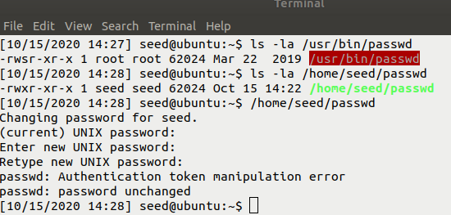

Similar is the case with chsh, the command didn’t execute successfully.

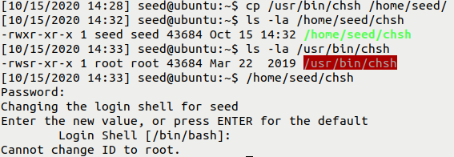

Su and sudo commands also didn’t execute as they are no more setUID programs after copying to our directory.

TASK 2

1. Even after copying the root privileges are maintained. As normal user, I was able to run the zsh command successfully. The effective uid is 0 (root).

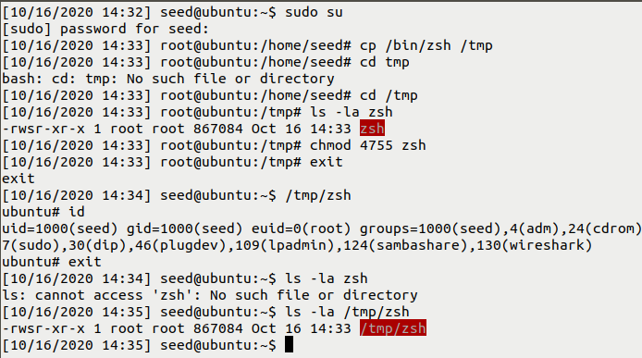

1. But normal user will not get root privileges while executing the copied /bash as we can see below. The UID is of the normal user – seed.

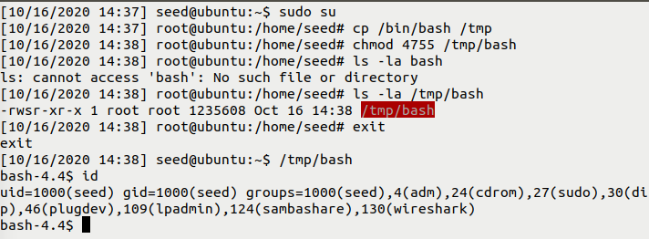

TASK 3